APK FILE Link (GitHub) - <https://github.com/cfothe200/Mobile-Development-CFOTHE200-S1712624/blob/master/app-debug.apk>

Video Link (GitHub) - <https://github.com/cfothe200/Mobile-Development-CFOTHE200-S1712624/blob/master/MobileCoursework.mp4>

Application Link (GitHub) - <https://github.com/cfothe200/Mobile-Development-CFOTHE200-S1712624/blob/master/MobileCoursework.zip>

# Design Report:

The project undertaken was to create a mobile application that would show earthquake data from around the UK using an external link and data parsing. This application was to be created using android studio and parsed data on the earthquakes to be displayed to the user. In this report the designs for the application will be discussed and the thought process that went into these designs to help understand the outcome of the application. This application was also to be displayed in both landscape and portrait screen settings.

## Start Page:

The start page for the application is the main page that the users will view and interact with. This page will appear when the application is loaded and list all the different earthquake instances that are parsed into the application. Each of these instances is separated by a horizontal line in the page and each different earthquake instance will display to the user the location it happened, the data and time of the earthquake as well as its longitude and latitude. These instances will also act as buttons that when clicked will take the user to a new page that will display all the information for that particular earthquake. Originally the designs also planned to have a date search function button on the start page, this button would then bring up a calendar, displaying each day within the month, this would then allow the user to select two different dates from the calendar and that would take the user to a page that displayed each earthquake within that time frame. Two methods were originally thought of to design this aspect, the first was the single button method and the second was a double button method, one to set the first date and one to set the second that would then search and display the data after the second date had been set. The main goal of the start page, other than to display the earthquake data to the user, is to be as user friendly as possible and simple to understand and show the user that the application is easily functional as there is only basic options labeled properly so that there functions are clear and easy to understand. The view of the application can be displayed in both portrait and landscape. On the landscape display nothing about the layout changes as the display on the page transitions well and is still clear and easy for the user to understand, however fewer earthquakes appear due to the limited screen space meaning the user will need to scroll down the page more to access other earthquakes. The design of this start page also incorporated a ‘scroll view’. This view allows for the page to be scrolled up and down, using touch or similar methods to allow for all of the earthquake instances to be stored, as if the scroll view is not used only around 6 of the instances would be available to the user at any one time and would require them to continuously move to a new page when looking for earthquakes that happened earlier in the timeline. The colour scheme for the application was kept simple with a white background and black text. This was selected as the white background helps to make the text stand out to the user and there is no contrast between colours so the text is clear and easy to read.

## Earthquake further information page:

The earthquake further information page is the second page of the application and it will appear when the user selects any earthquake instance from the start page of the application. The page will take the XML data it has taken from the pull parser and display it to the user. This page is laid out as a list view, using the earthquake adapter, to display various pieces of information about the selected earthquake. The pieces of information displayed on the page are the location of the earthquake, the date that the earthquake occurred and the longitude and latitude of the quake, these are all displayed on this page, same as the home page, as it allows for the user to know that they have selected the correct earthquake to view, as well as the fact that these are vital pieces of information about the instance. Other data displayed on this information page is the magnitude of the earthquake and the depth that it happened. This page will provide the user with the information they are looking for in a manner that is simple for the user to read and understand so that they clearly know what information they are looking at. This page may also be displayed in both portrait and landscape. This will allow the user to view the data in either display without difficulty and provide data that is still readable, and the user can understand what they are trying to view.

## Calendar Page:

This page would appear when the user clicks the date picker button within the home screen of the application. This will display a calendar page to the user starting in the current month, April for example, and display every day within that month. The user can the select a date within the current month or navigate to previous months using the arrows beside the current month, as they go through each month’s days will be displayed on the calendar view. This would allow the user to select a specific date from the calendar and then the calendar would reset to the current day, allowing the user to then select another day within the month they desire to then allow the application to display the months within this date range. This page would function purely as the calendar picker and once the dates are selected the user would be sent to a page containing only the earthquakes that happened in the specific months. This page would also function both on landscape and portrait ensuring that the calendar is accessible on both and aspects are positioned off the screen. However due to time constraints within the project this feature was not implemented but was still considered during the entire design stages of the application.

## Selected Date Earthquakes:

This screen is intended to look like the original start page, including the scroll view as depending on the range of dates selected by the user, there could be a large number of different instances that must be displayed. Just like the start screen this page will display the 3 aspects of the earthquake that can be used to identify it, the location it happened, the specific date that the earthquake occurred and finally the longitude and latitude of the earthquake. Again, like the original home screen each instance can be selected, and this will take the user to a page containing further information on the selected instance. This screen would be able to be displayed both on landscape and portrait views to allow the user to select how it is displayed on the screen. Also, the page will focus on being as simple and easy to understand for the user as an aim of this application is to be as simplistic and easy to understand as possible and be very accessible to all different types if people. However, again due to constraints with the project just like the date picker this feature of the application was not able to be implemented.

## Future Recommendations:

In the future of the application it would be recommended that the date picker and selected date pages be added to the application as it was originally mentioned in the specification and it allows the users to search for specific earthquakes, making the users experience more pleasant and simple. These pages can follow the designs suggested as it would be possible to make them fit the application by doing so. Another feature that may be added in the future could be a map function to allow users to select a specific area in the UK and then take them to a screen providing the user with all the earthquakes that have happened within that selected region. Another recommendation would be adding more visually pleasing aspects to the application, for example a more pleasing colour scheme, as although the current white background and black text with a blue header works and makes the application content clear, a better scheme may be chosen to catch the user’s attention more easily.

# Testing Report:

This section of the report will cover different methods for testing that have been used to test the earthquake information application, the methods looked at and eventually carried out were, white box testing and black box testing. The testing process of an application is vital as after the features of the application have been implemented it is important to ensure they are working as intended, do not cause any issue or errors when running the application and that each function gives the proper outputs to the user. This is why it is important to test each function of the application properly to ensure it works as intended and if not, resolve any errors found.

## White Box Testing:

The white box testing method is used to test applications when the person testing the application already has knowledge of the internal program functions and design as this aims to test different statements and conditions within the application. This form of testing comes with many advantages, one of these is that this type of test can be carried out at earlier stages in development as no graphical interface is required as the tester already knows how the application should function and how to test these functions. Another advantage of this testing is that due to the way it tests the application the tests will cover the majority if not all the different conditions and paths within the program to find any errors.

However, white box testing does have its own disadvantages, one of these is that the testing carried out on the system is very complex, therefor there is a need for experienced testers, and they must also have knowledge of the application and how it was created beforehand. Another disadvantage is that if the application goes through many iterations it can be difficult to keep the testing records and logs up to date and know which results are still relevant to the application.

## Black Box Testing:

This testing method is the opposite of white box testing mentioned above as that method requires prior in depth knowledge of the system being tested whereas black box testing is used when the tester has no prior knowledge of the development and coding of the system and the tests are based purely on the applications main requirements and functionality, this allows the application to be tested as if it was a random user attempting to carry out action on the application and see’s how its handles the user and if any errors occur during the process. Black box testing does come with many advantages, one of which is that because the tests are carried out by a user It highlights how the general users will access and use the application and shows any differences in what has been produced and the original specifications for the project. Another advantage of this testing method is that the tests don’t require an expert tester or anyone who has inside knowledge of the system; therefore, these tests can be carried out by anyone and require less resources to undertake.

However, this method does still have its own disadvantages as only the basic inputs and functions will be tested and unlike the white box testing method this does not go deeper into the many paths that the application has, therefor the testing the less thorough. Another disadvantage is that since the tests are basic when carried out on the system they may not actually be needed if the developer has carried out testing during the original development of the system as these functions would already have been tested.

After looking over and comparing these two testing methods and both the advantages and disadvantages that come with them the type of testing that was believed to fit the earthquake application best was black box testing. This method will be the main testing used to complete the testing phase of the application as it is the most applicable of the two methods. Black box is believed to be the most applicable to the project as it tests the overall functions of the application and ensures that these work as intended, this is vital as the users of the application will not be using it as in-depth as white box testing will go therefor it seems less relevant to this specific project.

Overall various tests have been carried out on the application with a focus on the black box testing method. These tests were carried out for various reasons, the main reason being to ensure that all the main functionality that was implemented into the application works as it is intended and will not provide users with any unexpected and unwanted errors during there time on the application. To carry out this testing a table or test log was created to store different pieces of information about each test, for example what tests were carried out, how they were carried out, the expected and actual results of the tests and finally comments on each test instance. Screenshots of the application will be provided along with the test logs. Finally these test logs will also document any tests that brought up errors within the application, expected output of the test as well as the actual output brought about by the test and finally a comment showing how this issue was resolved to be a reference point incase this issue ever occurs during future development.

## Test Logs:

|  |  |  |  |  |  |
| --- | --- | --- | --- | --- | --- |
| Test No | Test If | Action | Expected Result | Actual Result | Comments |
| 1 | Application loads | Open the earthquake application | Application runs | Application crashes | Application failed to load. (not enough text views to store all viewed information) |
| 2 | Application loads | Open the earthquake application | Application runs | Application runs | Removed data that was no required on home page from Earthquake Adapter Class |
| 3 | Scroll view on home page | User scrolls up and down page | Page moves displaying further earthquake instances | Page moves displaying more earthquake instances | Works as Expected |
| 4 | Earthquake takes you to more information page | User clicks on an earthquake instance | Page goes to the earthquakes further details | Application doesn’t change page | Earthquake is highlighted but stays on home page. |
| 5 | Earthquake takes you to more information page | User clicks on an earthquake instance | Page goes to the earthquakes further details | Application moves to next page | Added the action tag for info page into the manifest file (page was created manually not automatically therefor required to be added manually). |
| 6 | Further details of select earthquake is displayed | User clicks on an earthquake instance | Moves to info page and the further details are displayed | Details are displayed on a new page | Works as expected. |
| 7 | If details of correct earthquake are displayed | Open different earthquake instance | Displays appropriate details according to selected instance | Page displays appropriate details | Works as expected |
| 8 | Return button takes user from info screen to home screen | User clicks return button when on an earthquake information page | Return user to home page | The user is returned to the home page | Works as expected |
| 9 | Home screen is displayed appropriately in landscape | User rotates screen to landscape display | Page is displayed in landscape | Page gets displayed to the user in landscape and the earthquakes are displayed appropriately | Works as expected |
| 10 | Second screen is displayed in landscape | User rotates screen to landscape display | Page is displayed in landscape | Page gets displayed to the user in landscape and the earthquakes are displayed appropriately | Works as expected |

## Screenshots:

Home Screen Portrait:

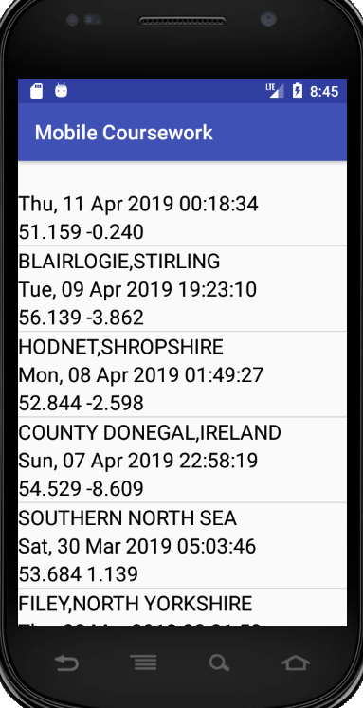

Home Screen Landscape:

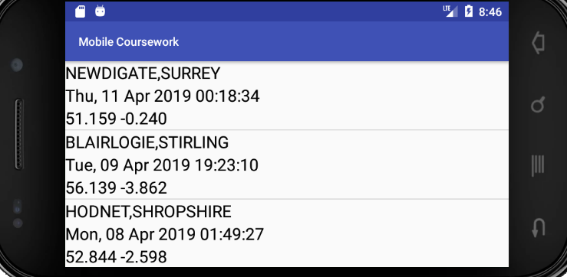

Info Screen Portrait:

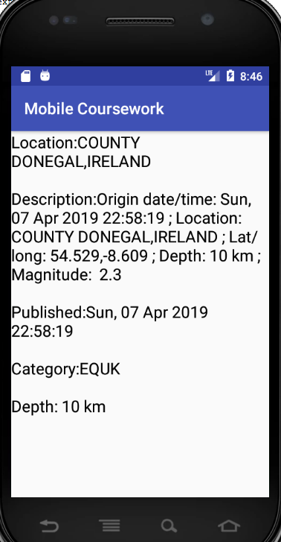

Info Screen Landscape:

